**Leader Overview**

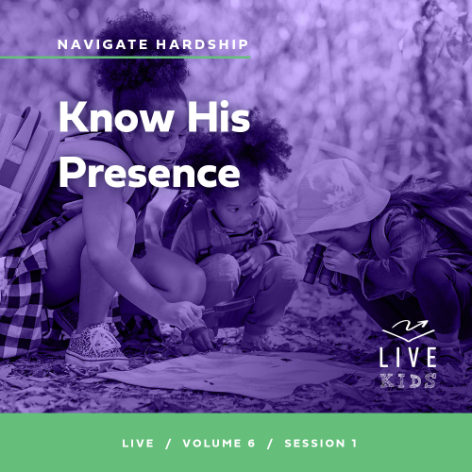

**Volume Overview**

**Navigate Hardship**

*Life is hard, even for believers. We all know it or discover it soon enough. Life tests our patience, our hope, and our sense of God’s presence. But we are not left hopeless in our challenges. God’s presence is more certain than even our hardships. Still, there are times in life that we need to be reminded that He is present. It’s in hardships that we learn to recognize it. We also learn to depend on God, to wait, and to look forward to His rescue.*

**Session Overview**

**Know His Presence**

*In this* **Live** *session, kids will discover that God is always close to them even when they face situations or hardships that make it seem He is absent or uninvolved. In the Bible story, Jesus was sleeping while a storm raged at sea, but He immediately responded when His disciples called out to Him. Similarly, kids will learn that the situations they face don’t determine who God is or if He is there for those who seek Him. He is always present no matter what we’re facing.*

**Bible Lesson**

The Disciples Call Out to Jesus in a Storm

[Mark 4:35–41](https://ref.ly/logosref/Bible.Mk4.35-41)

**Faith Fact**

I can trust God is with me.

**Faith Verse**

[Psalm 34:19](https://ref.ly/logosref/Bible.Ps34.19) (NLT)

The righteous person faces many troubles, but the Lord comes to the rescue each time.

**Preparing for the Session**

**Leader Preparation Time: 20–25 Minutes**

|  |
| --- |
| ***You Will Need***  ***Large Group***   * *Bible* * *Worship songs (Song suggestions: “Nothing is Impossible” Lyric Video by Planetshakers; “Only Wanna Sing” Lyric Video by Hillsong Young & Free: “Trust” Lyric Video by Hillsong Young and Free, “Surrounded (Fight My Battles)” Lyric Video by Upper Room)* * *For groups not using a phone or tablet only, add:*   *• Projector or TV*  *• Laptop*  *•* ***Faith Fact Slide***  ***• Faith Verse Video or Slide***  ***• Bible Lesson Video***  ***• Teaching Point Slides 1–3***   * *Shield prop (round sled, trash can lid, large pot lid, etc.)* * *Music to represent the calm time.* * *Way to play music (smartphone, CD player, etc.)* * *Floor-safe tape*   ***Small Group***   * *Clothespins, one per kid* * *Fine tip permanent markers* * *Optional: Whiteboard or sheet of paper* * *Optional: Stickers* * *Bibles for kids in the group to share* * *Soft ball* * *Optional: Smartphone to time activity* * ***Small Group Activity Page****, one per kid* * *Pencils or pens, one per kid* * *Crayons or markers*   *To access session content and videos from a computer, visit:* [*BibleEngagementProject.com/downloads*](https://bibleengagementproject.com/downloads) |
| ***Getting Ready***  ***Large Group***   * *Download videos and slides if needed.* * *Select worship song(s) and have them ready to play.* * *Read the Bible Lesson Scripture to prepare for teaching time.* * *Use the floor-safe tape to mark out the playing area for the game.*   ***Small Group***   * *Write the phrase “God is with me” on a whiteboard or paper if you have kids who need help with spelling.* * *Print copies of the* ***Small Group Activity Page****, one per kid.*   *First time leading* Live *for Kids? Check out the* [*Facilitator Guide*](https://0b769b0ed3569ef9d18b-f88d8272f61086866d50d048b43ef630.ssl.cf2.rackcdn.com/sites/biblengagementproject/Listen_Facilitator_Guide.pdf)*.* |

**Large Group**

**30 Minutes**

*See what’s needed at the beginning of the session.*

**Introduction**

Hello, everyone! Today will be spectacular, and I’m so glad I get to spend it with you. We’ll look at an important fact about facing hardships in our everyday life. Unfortunately, we’ll all face problems. Everyone, give me a big frown and thumbs down! *(Group response)* God is with us in everything. He will help us through any situation we face—good or bad. That’s good news! Everyone, give me a big thumbs up and a huge smile! *(Group response)*

Raise your hand if you’ve ever been in a tough situation that made you feel sad or scared. *(Group response)* Look around! We can all face hard things. But God wants to show us how to get through them. The first step is realizing that God is always with us. That’s what we’re talking about today!

How many of you would like to have an invisible forcefield? *(Group response)* Unfortunately, I don’t have any of those to give, but I do have this shield.

• *Hold up your “shield.”*

A shield is extremely useful in many situations, such as a neighborhood water balloon fight or as a sled on a snowy hill. What else would a shield be useful for? *(Allow responses.)* Those are great ideas! Today, we’ll talk about how God can be like a shield for us in hard times.

**Faith Fact**

That reminds me of our Faith Fact for today: **I can trust God is with me.**

• *Show the* ***Faith Fact Slide.***



Sometimes it can be hard to understand how God can be close to us if we can’t even see Him. Has anyone here ever felt that way? *(Group response)* I have, but believe me when I say that trust in God is something that all of us need when we go through our toughest time. Point up to the sky and back to yourself as we say our Faith Fact. **I can trust God is with me**. One more time. **I can trust God is with me**. Well done!

**Game**

**Shark Tag**

Today, we’ll play a game that goes with our Bible story. Our story takes place in a boat on the water. This game will help us think about why we must trust God to help us on the hardest days. Most of the time our life may seem normal. We can easily go about our day. But things can change quickly, and our life gets harder.

Here’s how the game works. Let’s pretend that our playing area is a lake. Your job is to move around safely. One person will be the shark and will stand in the middle of the playing area. When you hear the music play, you’ll move carefully. The shark can’t move. As soon as the music stops, the shark can join everyone else freely moving about. If the shark tags you, then you’re a shark, too. When the music starts again, the sharks have to freeze in place. Everyone else will keep on moving around in the lake. Let’s play.

• *Choose a kid to be the shark.*

• *Have kids line up along one wall or the taped line and start the music.*

• *Play as long as time allows. Congratulate the kids who get to the other side of the lake.*

This game reminds us how quickly things can go from safe to dangerous. That’s what happened in our Bible story. That’s why knowing God is with us anytime and anywhere makes it much easier to trust Him even if we can’t see Him. Let’s say the Faith Fact together: **I can trust God is with me**.

**Worship**

One way for us to show God that we trust Him is through our worship by singing. When we sing about how good God is, the amazing things He has done, and how He cares for us, it reminds us that God is the best One we could ever trust. Who is ready to worship God today? *(Group response)* Let’s worship Him together.

• *Lead the kids in singing one or two praise songs. See suggestions at the beginning of the session.*

**Bible Lesson**

Thanks for worshipping with me. When we worship God, we remember how amazing He has been to us. We can trust God because He loves us and we love Him. Remember our Faith Fact: **I can trust God is with me**. We’ll hear what the Bible says about trusting God. But first, let’s pray to get started.

**Prayer**

|  |
| --- |
| *Dear God, thank You for being so close to us all the time. Help us to see in Your Word today that You are always close enough to help us when life is hard or challenging. In Jesus’ name. Amen.* |

**Video Intro**

Just before we look at the Bible story, let’s watch this video.

• *Play* ***Bible Lesson Video***.

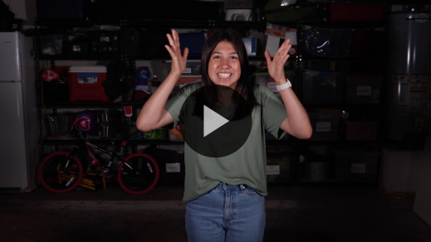

**Bible Story**

**The Disciples Call Out to Jesus in a Storm**

Have any of you ever been in a situation like Isa was in? One day you feel so close to God. The next day you see how many tough things are going on around you, and you wonder where He went. Maybe, you’ve never really felt that close to God. You wonder why other people say they feel God with them, but you don’t. That can be tough. Let’s take a look at the Bible story Isa was talking about to find out more.

**Teaching Time**

Jesus had just finished a long day of teaching large crowds about things like faith, living for God, and how the kingdom of God works. Then, He told His closest disciples that they should cross the lake to the other side. Easy work for the disciples since some of them were fishermen, right? *(Group response)*

How do you think Jesus felt after teaching all day? *(Allow responses.)* What about the disciples who traveled with Him? *(Allow responses.)* I’m guessing that they all were probably tired. Jesus was tired enough that He fell asleep in the boat. I don’t know if you’ve ever wondered if Jesus slept, but the Bible tells us that He did.

The task for the disciples was simple: get across the lake that some of them had sailed on and fished in for years. What kind of things could happen on this trip that might make it challenging to sail across this lake? *(Allow responses.)* Let’s find out how the disciples learned they could trust Jesus, no matter what challenges they faced on the water or in the rest of their lives. Our Faith Fact today is **I can trust God is with me.** Let’s say that all together. **I can trust God is with me**.

Grab your Bible or pull up a Bible app on your device. Turn to [Mark 4:35–41](https://ref.ly/logosref/Bible.Mk4.35-41).

• *In order to keep Large Group time moving along, we recommend that the leader reads the Scripture portions aloud.*

• *Optional: Remind the kids to mark this place with a bookmark so they can read it on their own at home.*

**1. Jesus and the disciples faced a serious storm.**

• *Show the* ***Teaching Point 1 Slide.***

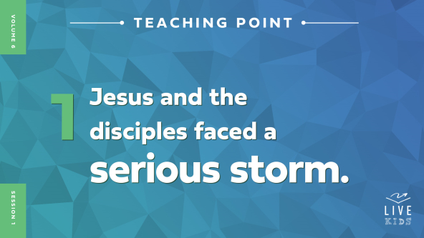

• *Read* [*Mark 4:35–37*](https://ref.ly/logosref/Bible.Mk4.35-37).

Wow! That weather changed very quickly. One moment they were sailing across the lake, and suddenly they were in the middle of a storm. This wasn’t just a simple rainstorm that was sprinkling water on them. This storm was causing waves to crash over the front of their boat. The situation was extremely dangerous, and they were at high risk of sinking.

Imagine you were with the disciples in that moment. They were panicking, frantically trying to figure out what to do to keep their boat from being turned over and completely overwhelmed by the waves. It was a literal life and death moment for them. What kinds of things do you think they were thinking? *(Allow responses.)*

• *Hold up the shield.*

Remember how we talked about a shield earlier? *(Group response)* It’s useful in many different situations, but it’s mostly helpful to protect whoever is holding it from whatever they hold it against. Now, let’s say I use this shield to stop an incoming water balloon from hitting me. If I hold this shield up against that attack, does it stop the water balloon from being thrown at me? *(Group response)* Of course not!

Jesus and the disciples faced a serious storm. It was a real, dangerous threat. It can be easy to wonder, *“Why wasn’t God with them, protecting them?”* God is always with us, and He is our Protector whom we can trust. Having God as our Protector doesn’t mean that the things we need protecting from will disappear. We can still face scary situations like the disciples did. Let’s see how the disciples handled the storm they faced on these treacherous waters.

**2. The disciples didn’t trust Jesus at first.**

• *Show the* ***Teaching Point 2 Slide.***

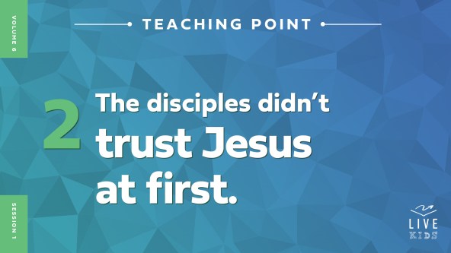

• *Read* [*Mark 4:38*](https://ref.ly/logosref/Bible.Mk4.38)*.*

So, Jesus must have been really tired because He slept during this crazy storm. The disciples were really bothered by this. They thought that Jesus didn’t care that they were about to drown. It didn’t seem like they trusted God was going to take care of them and protect them. What do you think you would have done in a situation like this? *(Allow responses.)*

It would be so cool if we each had our own personal invisible forcefield. We wouldn’t need to carry around a shield to protect us. It would keep the rain and bugs off us, and we would never need to worry about getting hurt. What do you think might happen over time if the forcefield was truly invisible so that we never saw it? *(Allow responses.)*

I think I would probably forget about it. Even though I know in the back of my mind that it’s there, I think that I might forget. For example, in a water balloon fight, just for a split second, I would freak out just a little bit if I saw a water balloon soaring through the air toward my face. What about you? *(Group response)*

God is always with us and always watches over us even though we don’t see Him. He is our Protector, and we can trust Him to help us get through anything we face. Sometimes when we’re in a difficult situation, we can forget that God, the God of the universe, has our back. Maybe it’s because we don’t think about His presence every day or because we don’t keep Him at the front of our mind, but He is here with us all the time. Let’s see what Jesus did after the disciples woke Him up.

**3. Jesus calmed the storm.**

• *Show the* ***Teaching Point 3 Slide.***

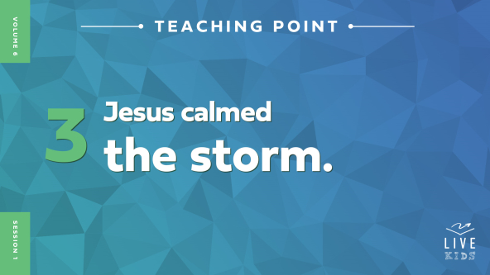

• *Read* [*Mark 4:39–41*](https://ref.ly/logosref/Bible.Mk4.39-41).

Think about what happened. Jesus got up from sleeping, told the weather what to do, and it listened. What? What do you think the disciples were thinking when that happened? *(Allow responses.)*

Then, Jesus asked them why they didn’t have faith. Jesus showed them that the power of God is stronger than even the worst storm. After witnessing such an incredible miracle, they were really shaken up. I would be, too.

Jesus’ followers knew that He was special, but Jesus surprised them with the power He had and what He could do. Jesus wanted them to trust that He had the power to save and protect them from anything, even something that seemed as out of control as a storm on the lake.

Jesus, the Son of God, was able to protect all the disciples in the storm. He showed that God is all powerful over every situation—even the weather. This brings up an important question: Will God protect you and me from every hard situation? This is hard to understand, so let’s work through it together. Listen carefully.

Remember that having a shield doesn’t stop the attack from coming. We talked about that already. Will God protect us from every situation we face and be our invisible forcefield? The short answer is no, and here’s why. God wants us to trust Him to protect us from many bad situations and to get us through the ones that we do face.

Even Jesus went through tough times. Guess what? Trusting God the Father during those situations was part of Jesus’ mission to share love with the world. Sometimes our trust in God is built even more when we are in the middle of something tough than if we had been shielded from it in the first place.

Remember our Faith Fact today: **I can trust God is with me**. Because God is with us, we can know that He will protect us when we need protection. He will give us the strength we need to face any hard situation that might come up in life.

**Prayer and Response**

*Consider playing a worship song softly in the background while kids pray.*

God wants us to trust Him. We can often be afraid, nervous, or frustrated, even if we know that God is with us. When we believe that He is with us, we can face anything that may come our way.

Today, we’ll pray and ask God to take away anything that gets in the way of us having the peace that comes from knowing He is with us. I want everyone to close both hands into a tight fist.

• *Pause while kids respond.*

This represents things that we hold on to that God doesn’t want us to hold, such as fear, anxiety, worry, anger, anything like that. God doesn’t want these to get in the way of us experiencing His peace. Today, we’ll let go of these things and choose to trust God. Open up your hands with your palms facing up.

• *Pause while kids do this.*

Now, think about something you’re facing that isn’t easy to trust God with. Let’s ask Him to help us to remember that He is with us and can help us with that problem.

• *Pause while kids seek God on their own.*

Let’s thank God for being with us always. We can ask God to show us how to be strong and brave in life’s tough times and to trust that He is always with us.

**Prayer**

*Optional: Have the kids repeat phrases of the prayer after you.*

|  |
| --- |
| *God, thank You for always being with me. Help me to trust that You are always here no matter what I’m facing. I don’t want anything to get in the way of me trusting You. As I open my hands, I pray that You would help me trust You more than anything else. Help me through my problems, protect me and strengthen me, and give me Your peace. Amen.* |

**Faith Verse**

That was very important to think about inviting God into our struggles. Our Faith Verse reminds us that even in life’s hard times, God is there to rescue us. He may not take away all the hard things we face, but we can always trust that He is with us!

• *Play* ***Faith Verse Video***.



[Psalm 34:19](https://ref.ly/logosref/Bible.Ps34.19) (NLT)

The righteous person faces many troubles, but the Lord comes to the rescue each time.

Let’s say that verse together one more time all at once. *(Group response)* Great work!

**Faith Fact**

Before we go to our small groups, let’s think about our Faith Fact again. **I can trust God is with me**.

• *Show the* ***Faith Fact Slide***.



Let’s say that Faith Fact together. **I can trust God is with me**. Point at the sky and then point back at yourself. Let’s say it again. **I can trust God is with me**.

• *Dismiss kids to Small Group time or to go home if your group time ends here.*

**Small Group**

**30 Minutes**

*This section can be done in conjunction with the large group or on its own if you do small groups with your kids. During Small Group time, the goal is to connect the kids with the Word of God and to each other. All activities are led by the small group leader.*

**Group Connection**

**“God Is with Me” Reminder Pin**

|  |
| --- |
| ***You Will Need***   * *Clothespins, one per kid* * *Fine tip permanent markers* * *Optional: Whiteboard or sheet of paper* * *Optional: Stickers*   ***Getting Ready***   * *Write the phrase “God is with me” on a whiteboard or paper if you have young kids who need help with spelling.* |

In our Bible story, we heard how the disciples didn’t need to be afraid of their circumstances because Jesus was with them. When we remember that God is with us, we can have God’s peace in the middle of the problems we face in our life. Today, we’ll make a reminder that God is with us wherever we go.

• *Give each kid a clothespin*.

• *Distribute the markers*.

On your clothespin, use a marker to write, “God is with me.” Then, you can decorate it however you’d like. When you go home, pin this clothespin on something you take with you lots of places like a backpack or a lunch bag. When you see it, remember that God is with you wherever you go.

**Bible Lesson Recap**

• *If small group activities are not immediately following large group time, you may want to read the Bible story passage before the discussion.*

|  |
| --- |
| ***You Will Need***   * *Bibles for kids in the group to share*   *No prep needed for this activity.* |

**Bible Story Review: The Disciples Call Out to Jesus in a Storm** [**Mark 4:35–41**](https://ref.ly/logosref/Bible.Mk4.35-41)

What was the most interesting thing about the Bible story we heard today? *(Allow responses.)* Those are great answers! To review, Jesus and His disciples sailed across a lake. The disciples were terrified by a crazy storm, but then they got to see Jesus calm the storm with just His words.

Why do you think the disciples shouldn’t have been afraid? *(Allow responses.)* It’s easier for us to answer that because we know the whole story. The disciples were with Jesus, God’s Son, and He had the power to make sure they would make it through anything they would face.

• *Give each kid a Bible and read the Bible story together.*

**Group Discussion**

*Feel free to use all or just a few questions as a jumping-off place for good discussion. Questions marked with * are designed for more conversation. Adjust the questions based on the age or maturity of your group. Typically, older kids will be able to dive a little deeper than younger ones.*

**Questions**

What was Jesus doing before they sailed?

What happened when they were in the boat on the water?

* How do you think you would have responded in that situation?

Do you think the disciples didn’t trust Jesus at all?

* Do you think the disciples thought about Jesus differently after He calmed the storm? If so, how?

How did Jesus feel about the disciples’ response to the storm? (See verse [40](https://ref.ly/logosref/Bible.Mk4.40).)

* When have you seen someone trust God during a hard time? How could you tell?

* Does God protect us from every bad thing that could happen to us?

* How can you trust God more this week?

**Live It**

**Faith Fact**

Our Faith Fact today is **I can trust God is with me.** Jesus showed the disciples that they could trust Him to be there for them when they were scared and in danger.

Earlier we made reminder clothespins that will help us remember that God is with us, especially in the middle of our problems. I want each of you to tell us where you’ll put your reminder pin and why you are choosing that spot.

• *Let kids share with the rest of the group where they will place their reminder pin.*

**Challenge**

The challenge for this week is not only to remind yourself that God is with you, but also to encourage someone else you know who is going through a hard time that God is with them. You never know how much help your encouragement could bring someone else who needs to know that God is with them.

**Prayer**

*Finish group discussion by sharing prayer requests and praise reports. Keep track of your small group’s prayer requests and review them each time you meet.*

• *Have kids share and pray for each other’s prayer requests.*

|  |
| --- |
| *Dear God, thank You for hearing us when we pray. Please help us to trust that You are with us in every difficult and joyful moment. We trust You will be our strength in all of them. In Jesus’ name we pray. Amen.* |

**Faith Verse Review**

|  |
| --- |
| ***You Will Need***   * *Soft ball* * *Optional: Smartphone to time activity*   *No prep needed for this activity.* |

Our Faith Verse is [Psalm 34:19](https://ref.ly/logosref/Bible.Ps34.19). God wants us to trust that He is with us when we face troubles in our life. Let’s go over it together!

• *Show* ***Faith Verse Video***.



[Psalm 34:19](https://ref.ly/logosref/Bible.Ps34.19) (NLT)

The righteous person faces many troubles, but the Lord comes to the rescue each time.

When we trust that God is with us, we can get through our troubles and have peace that only comes from God. Let’s review our Faith Verse as a group one more time. Try to memorize it because you will need to know it for the Faith Verse game.

• *Say the verse as a group a couple of times.*

**Faith Verse Fun**

**Toss Across**

All right, now it’s time to put our knowledge of the Faith Verse to the test. We’ll sit in a circle on the floor, and one person starts the game with a ball. For the first round or two, we’ll pass the ball and each say one word at a time from our Faith Verse. When you’ve said the word that comes next, pass the ball on to the next person in the circle. We’ll keep doing this until we say the whole verse. If someone gets stuck, they can call on the rest of us for help on the next word. When we get it down really well, we’ll time ourselves to see how fast we can say the verse.

• *Say the verse one word at a time, having kids pass the ball around the circle after each word.*

• *Time the group saying the verse and challenge them to a speed competition against the clock if time allows.*

Great job, everyone! Even memorizing this Faith Verse will help transform your mind, which will help you trust God with difficult problems.

**Activity Page**

**Journal Page**

|  |
| --- |
| ***You Will Need***   * ***Small Group Activity Page****, one per kid* * *Pencils or pens, one per kid* * *Crayons or markers*   ***Getting Ready***   * *Print copies of the* ***Small Group Activity Page****, one per kid.* |

Our Faith Fact from today is **I can trust God is with me**. We also talked about what we can do to remind ourself and others that God is with us.

• *Hand out a copy of the* ***Small Group******Activity Page,*** *a pencil, and crayons to each kid.*

In our Bible story, the disciples got to witness Jesus commanding the storm to stop. Nothing is too difficult for God. Think about what situation you need God to calm in your life or for someone you know. Then write or draw about it on the Activity Page. You can color the picture of Jesus and the disciples in the boat during the storm.

• *Talk with kids individually about what they are writing or drawing.*

**Dismissal**

Remember that God wants us to trust that He will lead us through all the hard times we face. When we follow Jesus and His Word, we can know God is with us in any tough time that comes our way!

**Prayer**

|  |
| --- |
| *Dear God, please help us to trust that You are with us. When we know You are close, we can make it through anything. Help us to remember this and to encourage others with this truth also. In Jesus’ name. Amen.* |

**Faith Fact Recap**

• *Show the* ***Faith Fact Slide***.



Remember God doesn’t just want to help others in their hard times. He wants to help you and to use you to encourage others. Remember the Faith Fact? Let’s say it together. **I can trust God is with me.** I’m so glad you came today. I can’t wait to see you next time**.**

• *Send home the* ***Small Group******Activity Page*** *and each kid’s God Is with Me reminder pin.*

• *Remind parents that there are* ***Family Devotions*** *available on the app to do with their kid.*

• *Tell everyone the date and time for the next session.*